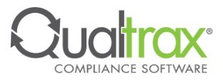
Replication Setup

Pre-Requisites:
- ‘Replication Administration’ Permission
- Access to the Output location

- Navigate to the Replication page in the Administration tab.
- Select ‘Add Replication’.
- The New Replication menu will appear.
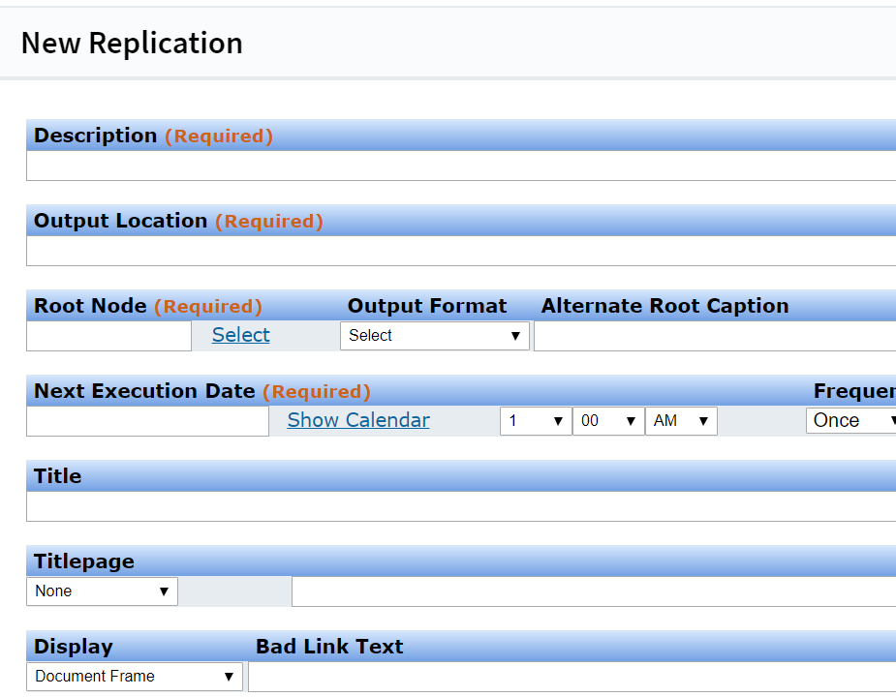

- Add in the details to match the Replication you would like to set up.
Description – A summary of the replication task.
Output Location – The network location where the webpage and document files output are exported to. Example - C:\Program Files\Qualtrax\Replication
Root Node – The tree branch being replicated. This could be the entire tree from the root folder or a specific folder.
Output Mode – Available options are Document Tree form or list form. The documents will show as closely as possible to the actual Qualtrax tree or as a list of documents.
Alternate Root Caption - the root folder name for the replicated Documents Tree.
Leave this blank, unless you'd like it to differ from how it appears in your Qualtrax
Documents Tree.
(This is just a summary of the settings and the ones that often need the most troubleshooting. The other settings are user preference and based on what type of replication is used. I.E. – SharePoint, Webpage, etc.)

Common Issues with Replication:
Error message ‘Unable to Access Remote Directory’ – This usually occurs because the account running the Qualtrax Service does not have proper access to the Output Location. If a path like C:\Program Files\Qualtrax\Replication or a shared network path, the permissions to the folder can be checked. Ideally, the account will have Full Control at the Top-Level folder. Read/Write/Modify could also be used if Full Control is not allowed.

